Frequently Asked Questions (FAQs)

Level 5 Operations/Departmental Manager Apprenticeship with NPQSL or NPQML

What is an apprenticeship?
An apprenticeship is a job with a formal programme of training.
Apprenticeships are work-based training programmes that are designed to help employers train people for specific job roles. At the same time, apprentices get a paying job with valuable training while they work towards a nationally recognised apprenticeship standard.
An apprenticeship can be for new or existing staff

Who is eligible for this apprenticeship programme?
Anyone in a job role who will benefit from substantial new learning to carry out the role.
An operations/departmental manager is someone who manages teams and/or projects, and achieving operational or departmental goals and objectives, as part of the delivery of the organisation’s strategy. They are accountable to a more senior manager or business owner. Working in the private, public or third sector and in all sizes of organisation, specific responsibilities and job titles will vary, but the knowledge, skills and behaviours needed will be the same.
Key responsibilities may include creating and delivering operational plans, managing projects, leading and managing teams, managing change, financial and resource management, talent management, coaching and mentoring.
Typical job titles may include:
For NPQSL- a deputy headteacher, a SEN coordinator, an assistant headteacher, or other senior staff member.
For NPQML- key stage leader, a curriculum leader, a pastoral services leader, a subject leader or head of a department.

Entry requirements?
No age restrictions
Minimum 30 hours working week
There are residency conditions:
https://www.gov.uk/guidance/apprenticeship-funding-rules-for-employer-providers/annex-a-eligibility-criteria-who-we-fund
5 GCSE’s at Grade C (4) or higher including English and maths or able to achieve Level 2 English and maths whilst on programme.
- Certificates or evidence on the PLR will be required for any exemption from sitting English and maths.
- Lost certificates – please contact your awarding organisation for copies
- If you have no evidence, we will support you to achieve Level 2 Functional skills
The apprentice is paid a lawful wage
The apprentice cannot contribute towards the cost of the apprenticeship
An initial assessment must consider whether the individual already possesses any of the training content e.g. the knowledge, skills and behaviours required by the apprenticeship:
- It is important to know the apprentice’s starting point so that the training plan does not duplicate prior learning.
- Any existing relevant qualifications will be checked against the Standard criteria during the initial assessment to ensure there is no duplication.
- Significant new learning must be required.
Only knowledge skills and behaviours in the Apprenticeship Standard are relevant, existing non-relevant qualifications at the same or higher level do not exempt learners from the programme, e.g. a degree in landscape design
https://www.instituteforapprenticeships.org/apprenticeship-standards/operations-departmental-manager/

Length of programme?
Typically, 15 to 18 months

What qualifications will I gain?
- Nationally recognised Level 5 apprenticeship standard accredited by industry regulatory bodies.
- The DfE accredited National professional Qualification (NPQs), NPQML or NPQSL.
- On completion, apprentices can register as full members with the Chartered Management Institute and/or the Institute of Leadership & Management, and those with 3 years of management experience can apply for Chartered Manager status through the CMI.

Why is there one Apprenticeship at level 5 for both NPQ programmes?
We are offering ML and SL NPQ’s as part of the same Level 5 Operations/Departmental Manager because:
The distinct nature of the NPQ’s will be appropriate for middle or senior leaders, however the occupations the apprenticeship has been written for is designed to be wide ranging and diverse and relevant to managers at different levels.
The Apprenticeship Standard states:
An operations/departmental manager is someone who manages teams and/or projects, and achieving operational or departmental goals and objectives, as part of the delivery of the organisations strategy. They are accountable to a more senior manager or business owner. Working in the private, public or third sector and in all sizes of organisation, specific responsibilities and job titles will vary, but the knowledge, skills and behaviours needed will be the same. Key responsibilities may include creating and delivering operational plans, managing projects, leading and managing teams, managing change, financial and resource management, talent management, coaching and mentoring. Roles may include: Operations Manager, Regional Manager, Divisional Manager, Department Manager and specialist managers

How is training delivered?
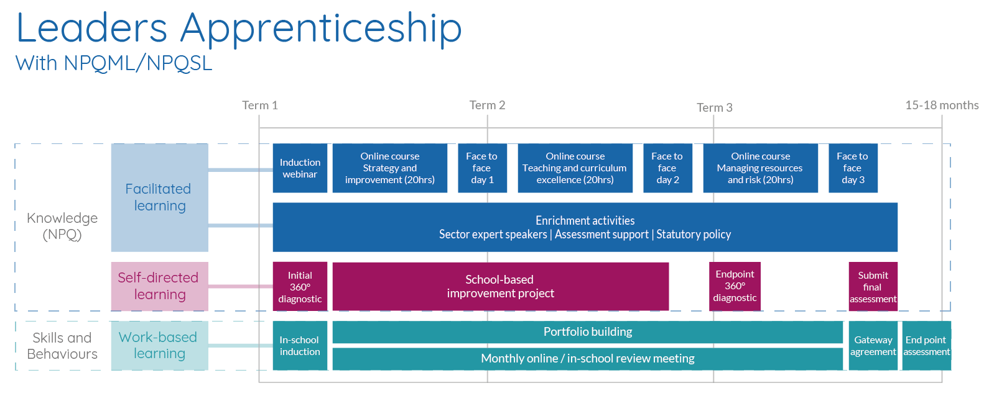

The apprenticeship is a work-based qualification, which means that the majority of the training and assessment for the apprenticeship will be completed at your workplace. You will need to build an apprenticeship eportfolio of evidence. Your Apprenticeship Tutor will observe you in the workplace and guide you on which pieces of work-based evidence are suitable for your portfolio.
Delivery will also be through webinars, online courses and briefings and three face to face training days offsite.
Throughout your apprenticeship you will have monthly remote visits and three-monthly face to face visits with your Apprenticeship Tutor to carry out reviews and observations and support you and your employer.
Once you have completed all the criteria for the apprenticeship and mock tests you will have a Gateway meeting with your Tutor and Line manager/Mentor to agree you are ready for your End Point Assessment (EPA). The EPA is completed to assess the knowledge, skills and behaviours that you have learnt throughout the apprenticeship.
- Multiple choice online knowledge test
- Structured Competency based interview (telephone, live media, online) – 15 minutes
- Assessment of online portfolio of evidence
- Work based project presentation and Q and A – 15 minutes
- Professional discussion relating to continuing CPD – maximum 1 hour
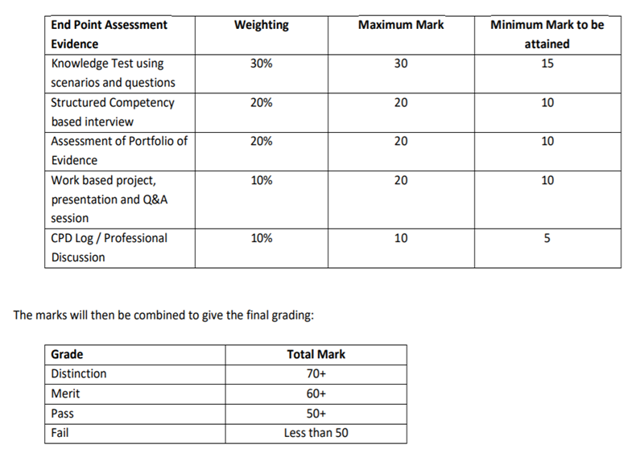

How much will I earn?
If you are over 19 you must be paid at least the Apprenticeship Minimum Wage of £4.15 an hour, however many employers pay more than this and the average weekly wage is £200.
If you are 19 after completing the first year of your apprenticeship, you must be paid at least the full National Minimum Wage.
All apprentices are employed and have a contract of employment. You are counted as a regular employee so get all the benefits such as holiday and sick leave as well.

What types of apprenticeship are available?
There are three levels of Apprenticeship:
Level 2: Intermediate Level Apprenticeship (equivalent to five A* GCSEs)
Level 3: Advanced Level Apprenticeship (equivalent to two A-Levels)
Level 4, 5 and 6: Higher Apprenticeship (Foundation degree level)

What do I do when I’ve finished?
It is up to you what you do when you have finished your apprenticeship. There may be an opportunity to stay on at the same company and progress to the next level of apprenticeship or you may want to look for a new job or professional development opportunity.

How do I apply?
Applying for an apprenticeship is like applying for a job so you will have to go through an application process.

Can I change employer during the programme?
Yes, apprentices can move employers but they must check that the new employer is happy to support them on the programme and the employer will need to complete checks and contracts with us first.

20% Off-the-job training
https://www.gov.uk/government/publications/apprenticeships-off-the-job-training
- Off-the-job training is about upskilling an individual to reach full occupational competency, not accrediting their existing skills.
- Off-the-job training must make up at least 20% of the apprentice’s normal working hours (paid hours excluding overtime) over the planned duration of the apprenticeship.
- Off-the-job training must be away from the apprentice’s normal working duties and must teach new knowledge, skills and behaviours relevant to their specific apprenticeship.
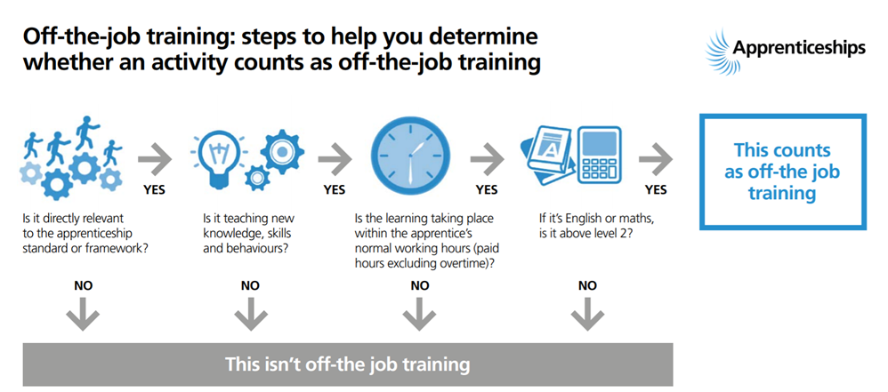
- You can deliver off-the-job training in the apprentice’s normal workplace or at an external location.
- Progress reviews and on-programme assessment do not count towards 20% off-the-job training.
- Apprentices may choose to spend additional time training outside paid hours, but this must not be required to complete the apprenticeship.
- If training must, by exception, take place outside of the apprentice’s normal working hours, e.g. in an evening or at a weekend for an apprentice that normally works Monday to Friday between 9-5, we would expect this to be recognised, for example through time off in lieu or by an additional payment to the apprentice.

Benefits of OJT
Apprenticeships are about upskilling an individual. Reaching occupational competency takes time.
- Many employers and apprentices have praised the positive effect off-the-job training has on their productivity
- Apprentices feel valued by the significant investment in their training.
- It can be delivered flexibly, for example, as a part of each day, one day per week, one week out of five or as block release
- You may already have existing training programmes or materials you can use to deliver elements of the apprentice’s off-the-job training.
- We have developed a range of delivery styles to suit employer and apprentice needs. Employers should work with us to decide when and where off-the-job training should take place and who is best placed to deliver it.
- Learning support - To be successful, learners may need a range of approaches and support, which will be targeted appropriately. As well as material assistance, such as physical adjustments or access to accessibility software, some apprentices may benefit from additional time, revision or personal support from their training provider, to help them to stay on track and to achieve specific knowledge, skills and behaviours.
- Develops strategic leadership skills and behaviours
- Improves core management techniques
- Focused learning experience
- Builds leadership capabilities to motivate and inspire your teams
- Builds self-awareness
- Addresses real organisational issues
- For those that are engaged on an apprenticeship there may be an initial loss of productivity, due to the time the apprentice is engaged in training, but in the long term the new skills that the person brings back to the workplace, which makes them fully occupationally competent, should compensate for this.
- The importance of off-the-job training to a quality apprenticeship was emphasised in the Richard Review of Apprenticeships and more recently in Taking Training Seriously, a report by the Gatsby Foundation which compared English apprenticeships to those in other countries. This report reinforced the need for off-the-job training and concluded that 20% should be the bare minimum if England is to compete with the strongest apprenticeship programmes internationally.

- Ofsted and the Quality Assurance Agency for Higher Education (QAA) have also highlighted the importance of off-the-job training to a quality apprenticeship in their various publications.
- A key element of Ofsted’s inspection regime is a judgement about how well apprentices make progress from their starting points i.e. what an apprentice can do as a result of their training and experience on the apprenticeship programme that they were unable to do before.

OJT examples
- Research
- Networking events
- Seminars
- Shadowing others
- Employer induction programme, e.g. conflict resolution and corporate induction as these are part of the required knowledge.
- Reflective learning
- Self-directed distance learning (where the apprentice is working on their own with no real-time support)
- Interactive online learning (virtual classrooms where the learner can receive support, in real time, from their training provider).
- Practical training
- Mentoring
- Time writing assignments
- Lectures, role playing, simulation exercises
- Online learning
- Industry visits
- Learning support

Apprenticeship advantages over stand-alone NPQ
- Dedicated Apprenticeship Tutor to support the apprentice and employer throughout the programme including regular reviews
- A small amount of additional knowledge (through formal learning and applied according to business environment)
- Support to gain and evidence more skills in the workplace acquired and demonstrated through continuous professional development.
- Support to develop behaviours in the workplace- taking responsibility, inclusivity, agility and professionalism
- Bringing learning together to build an ePortfolio of evidence including a project
- End Point assessment

How much does it cost? Funding
£7000 but:
Apprenticeship funding is available for employers from the government. The size of the funding employers receive varies depending on whether they pay the apprenticeship levy or not. Non- levy paying companies currently pay 5% of the cost with the government paying the rest but BPN may be able to find support for SME’s for this. For levy paying employers the funds are drawn from their levy accounts or topped up by the government if they have insufficient funds.
https://www.apprenticeships.gov.uk/employer/how-much-is-it-going-to-cost
- The entire apprenticeship is eligible for funding
- The apprentice cannot pay towards an apprenticeship
- Resits may incur extra costs to the employer
How are apprenticeships paid for and are they affordable?
Payments are spread across the entire lifetime of the apprenticeship - taken each month by your training provider. This means that you don’t have to meet the full cost of the apprenticeship at the start of the training. You just need enough funds in your account to meet the monthly payments. In addition, 20% of the cost of the apprenticeship will be held back and taken from your Digital Apprenticeship Service(DAS) online account at the end of the apprenticeship.
Do Levy funds run out?
Yes. Levy funds will expire 24 months after they enter your digital account unless you spend them on apprenticeship training. For example, funds that entered your account in July 2019 will expire in July 2021.If you don’t use them, you will lose them. The account works on a first-in, first-out basis. Whenever a payment is taken from your digital account it automatically uses the funds that entered your account first.
What happens if an employer’s Levy funds doesn’t cover the full cost of training?
If an employer pays the Apprenticeship levy but their funds don’t cover the full cost of the apprenticeship training they would like to buy, then additional support is available. The government will pay 95% of the additional costs (up to the maximum of the relevant funding band) -with you as the employer ‘co-investing’ 5%. We may be able to find external funding for the 5% if you need us to.

